**FUZZY Logic Example Calculations**

Size = 8

Range = 25

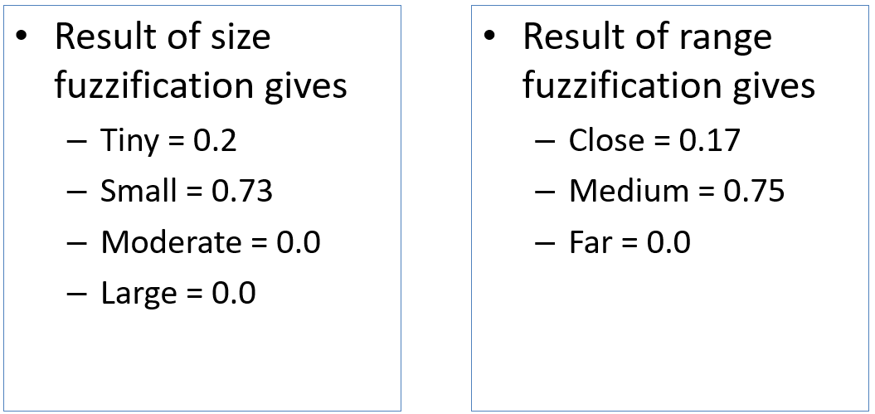

Rule matrix

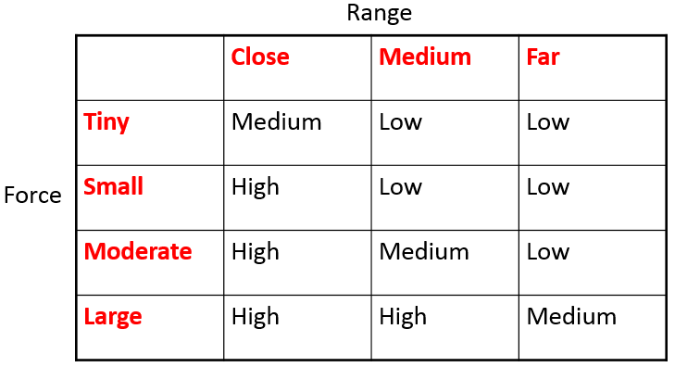

AND is MIN, OR is MAX

**Low is**

( Medium AND Tiny ) OR ( Medium AND Small ) OR ( Far AND NOT(Large) )

( 0.75 AND 0.2 ) OR ( 0.75 AND 0.73 ) OR ( 0 AND NOT(0) )

0.2 OR 0.73 OR ( 0 AND 1 )

0.2 OR 0.73 OR 0

0.73

**Medium is**

( Close AND Tiny ) OR ( Medium AND Moderate ) OR ( Far AND Large )

( 0.17 AND 0.2 ) OR ( 0.75 AND 0 ) OR ( 0 AND 0 )

0.17 OR 0 OR 0

0.17

**High is**

( Close AND NOT(Tiny) ) OR ( Medium AND Large )

( 0.17 AND NOT(0.2 ) OR ( 0.75 AND 0)

( 0.17 AND 0.8) OR ( 0.75 AND 0)

0.17 OR 0

0.17